Exercises

Object Oriented Programming

Problem Statement
Consider a Library of a book store. There are books in this library and each one is of various types, such as Novel, Poems, Short Story and Text Book. There may be several copies of a particular book in a library. All books have the following information: an author, a title and a page count. All books in a Library are stored in ascending alphabetical order according to their authors. Also each book have a price which is calculated in a different manner for each book type. It is also possible to combine libraries. Books can be listed by their types.

Purpose of the Example is to teach:
- Object-oriented topics
- Abstraction
- Abstract Book class (calculating book price is abstract)
- Inheritance
- Book types (Novel, Poems etc.)
- Encapsulation
- author, title, noOfCopies are private fields while pageCount is protected in Book class.
- Many method is public.
- Interfaces
- java.util.List<T>
- java.lang.Compareable<T>
- Java related topics
- Generics (List<Book>, Comparable<Book>, etc.)
- List<Book> denotes list of books.
- Built-in interfaces (List, Comparable) and classes (Collections, ArrayList)
- Comparison in Java (usage of Comparable interface)
- Collections.sort() method sorts implementations of List interface (ArrayList, Vector, etc.) by using compareTo() methods of their elements.
- Usage of equals() method
- Implementations of List interface (ArrayList, Vector, etc.) uses equals() method of an object to check whether they contain that object (reference or state equality) or not.

Design

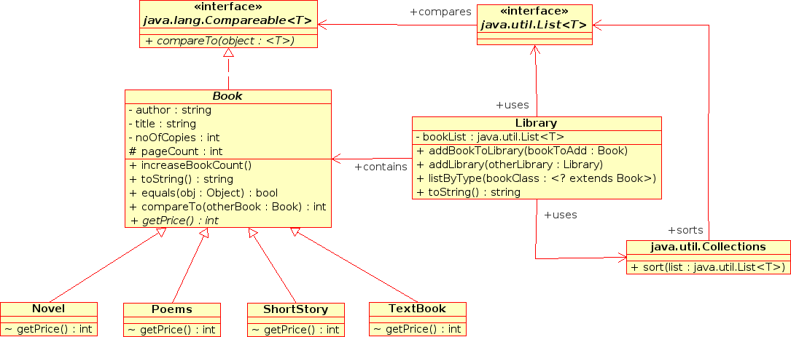

Library.java

package library;

import java.util.ArrayList;
import java.util.Collections;
import java.util.Iterator;
import java.util.List;

public class Library {
private List<Book> bookList;

// Constructor
public Library() {
bookList = new ArrayList<Book>();

}

// Add bookToAdd to privateLibrary. If there is a copy add 1 to number of
// copies.
public void addBookToLibrary(Book bookToAdd) {
if (!this.bookList.contains(bookToAdd)) {
this.bookList.add(bookToAdd);
}
bookToAdd.increseBookCount();
Collections.sort(this.bookList);
}

// Add all books of another library to this library.
public void addLibrary(Library otherLibrary) {
// this.bookList.addAll(otherLibrary.bookList); // wrong wrong wrong
Iterator<Book> iterator = otherLibrary.bookList.iterator();
while (iterator.hasNext()) {
Book book = iterator.next();
this.addBookToLibrary(book);
}
}

// List all book by according to their types.
public void listByType(Class<? extends Book > bookClass) {
Iterator<Book> iterator = this.bookList.iterator();
while (iterator.hasNext()) {
Book book = iterator.next();
if (book.getClass().equals(bookClass)) {
System.out.println(book.toString());
}
}
}

// Convert library to String.
public String toString() {
String stringRep = "\n";
Iterator<Book> iterator = this.bookList.iterator();
while (iterator.hasNext()) {
Book book = iterator.next();
stringRep += book.toString() + "\n";
}
return stringRep;
}
}

Book.java

package library;
abstract public class Book implements Comparable<Book> {
private String author, title; // Book info.
private int noOfCopies; // No. of copies library has
protected int pageCount;

// Constructor
public Book(String author, String title, int pageCount) {
this.author = author;
this.title = title;
this.pageCount = pageCount;
}

// Get author.
public String getAuthor() {
return this.author;
}

// Get the book count.
public int getCount() {
return this.noOfCopies;
}

// Get book title.
public String getTitle() {
return this.title;
}

// We get one more copy of this book.
public void increseBookCount() {
this.noOfCopies++;
}

// Convert a Book object to String for display purposes.
public String toString() {
String stringRep = "[Author: " + this.author + ", ";
stringRep += "Title: " + this.title + ", ";
stringRep += "Page Count: " + this.pageCount + ", ";
stringRep += "Type: " + this.getClass().getSimpleName() + ", ";
stringRep += "Number of copies: " + this.noOfCopies + "]";
return stringRep;
}

@Override
public int hashCode() {
final int prime = 31;
int result = 1;
result = prime * result + ((author == null) ? 0 : author.hashCode());
result = prime * result + noOfCopies;
result = prime * result + pageCount;
result = prime * result + ((title == null) ? 0 : title.hashCode());
return result;
}

@Override
public boolean equals(Object obj) {
if (this == obj)
return true;
if (obj == null)
return false;
if (!(obj instanceof Book))
return false;
final Book other = (Book) obj;
if (author == null) {
if (other.author != null)
return false;
} else if (!author.equals(other.author))
return false;
if (noOfCopies != other.noOfCopies)
return false;
if (pageCount != other.pageCount)
return false;
if (title == null) {
if (other.title != null)
return false;
} else if (!title.equals(other.title))
return false;
return true;
}

@Override
public int compareTo(Book otherBook) {
return this.author.compareTo(otherBook.getAuthor());
}

abstract public int getPrice();
}

Novel.java

package library;

public class Novel extends Book {

public Novel(String author, String title, int pageCount) {
super(author, title, pageCount);
}

@Override
public int getPrice() {
return this.pageCount * 500;
}
}

Poems.java

package library;

public class Poems extends Book {

public Poems(String author, String title, int pageCount) {
super(author, title, pageCount);
}

@Override
public int getPrice() {
return (this.pageCount / 2) * 700;
}
}

